Educational Excursion Programme at Pasupati AquaticsPvt. Ltd.
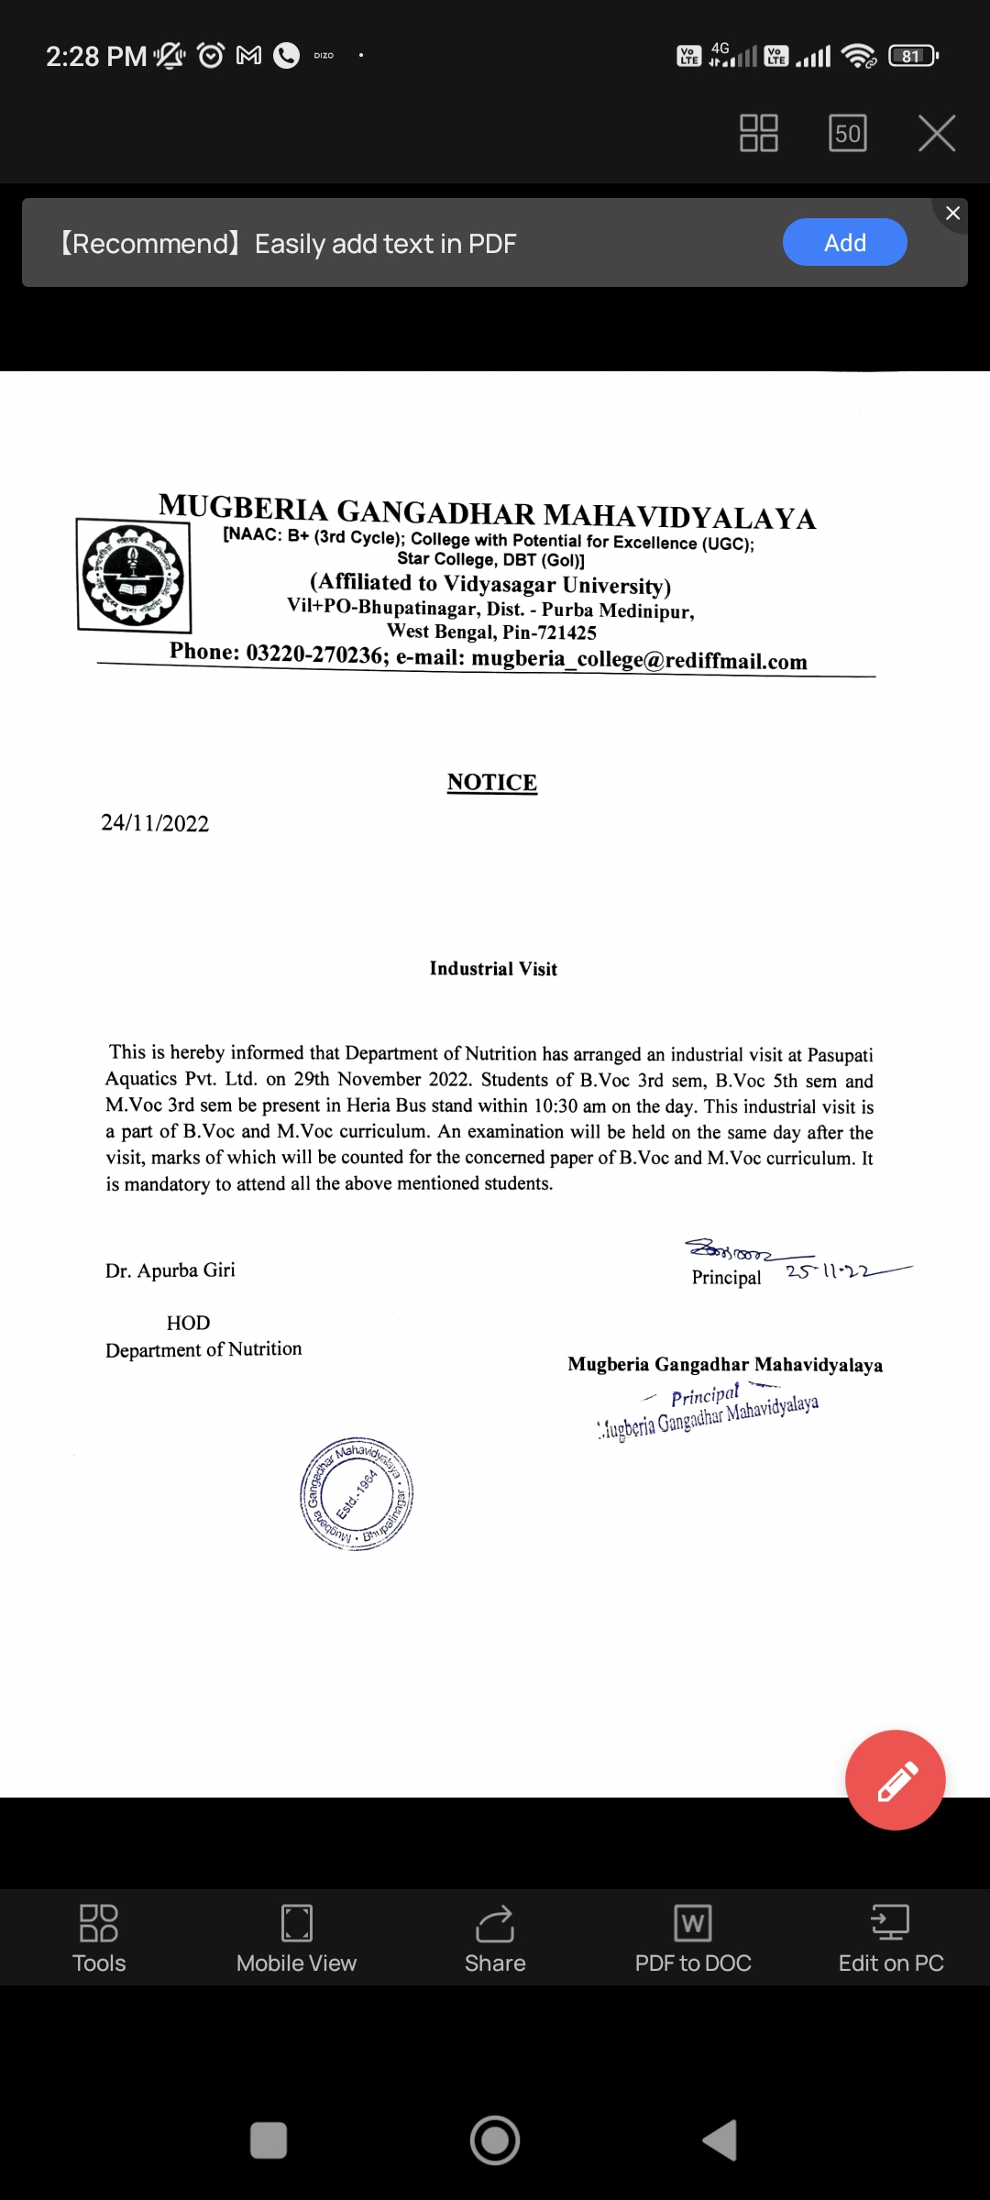

REPORT:
An industrial visit was organized at Pasupati Aquatics Pvt. Ltd., Heria, Purba Medinipur, WB, on 29.11.2022 under the supervision of Ms. Sruti Mandal (Training and Placement Coordinator), Dr.ApurbaGiri (Head, Nutrition Dept), Mrs. Sucheta Sahoo (SACT) and Mr. Prabir Jana (SACT) of Mugberia Gangadhar Mahavidyalaya. Total 71 (F-41,M-30) students of M.Voc 3rd Sem, B.Voc 5th Sem and B.Voc 3rd sem of Department of Nutrition, Mugberia Gangadhar Mahavidyalaya participated in this industrial visit. In this industrial visit students and teachers were enriched with the knowledge of Black Tiger and Vannamei Shrimp reception, cleaning, head and cell removing, freezing, IQF, packaging, storage and transportation of it under guidance of Mr. Dipankar Paul, Manager Human Resource, Pasupati Aquatics Pvt. Ltd., Contai.

PHOTOS:
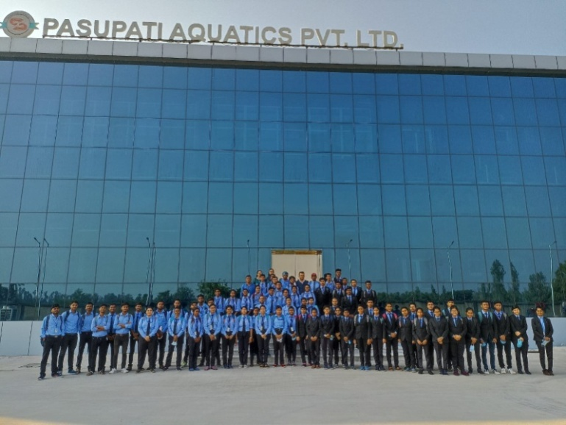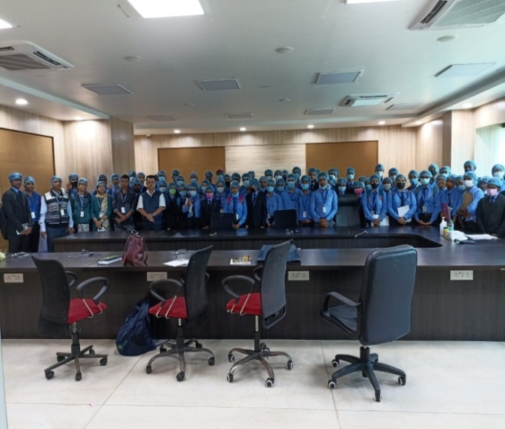Attendance of Participants:

FEEDBACK:
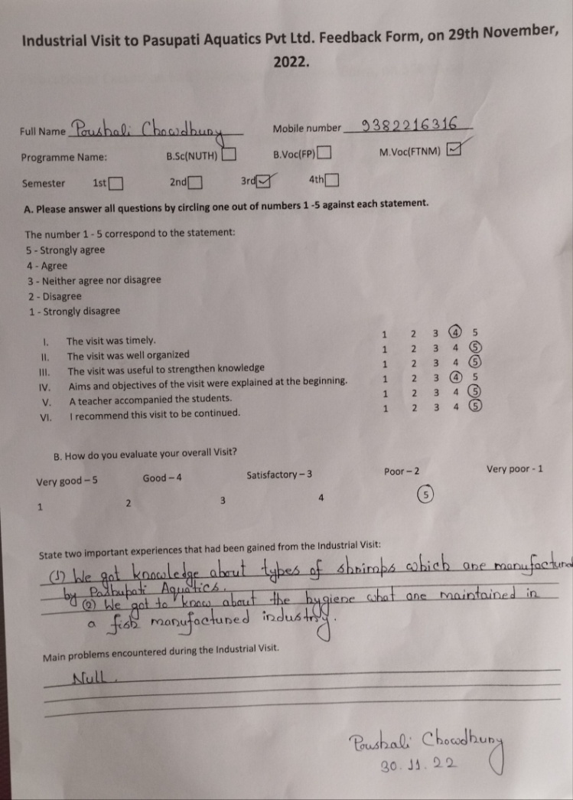
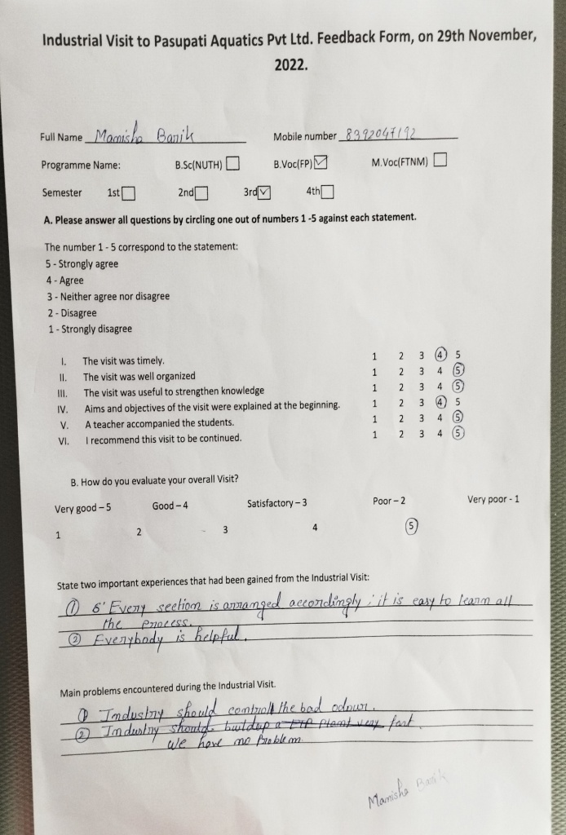

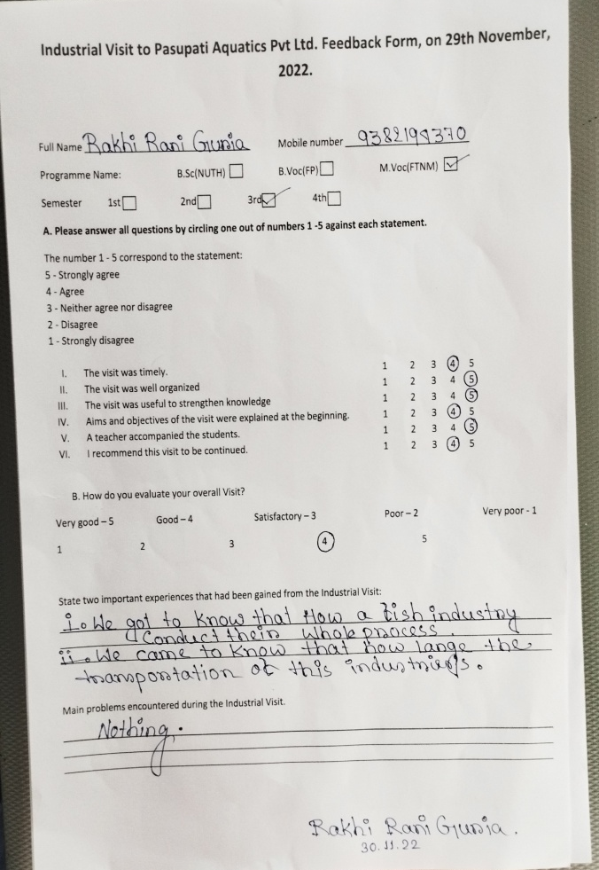
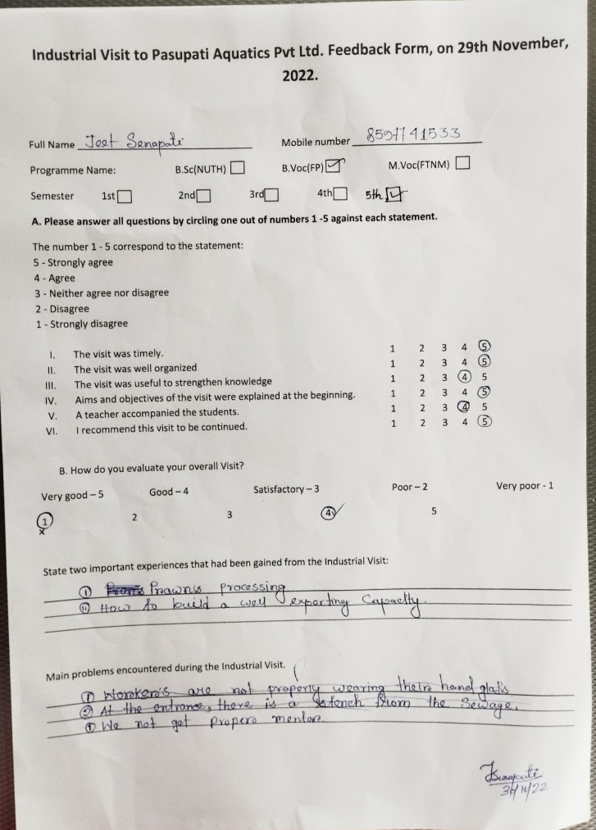

Resolution:
- In this industrial visit enriched with the knowledge of Black Tiger and Vannamei Shrimp reception, cleaning, head and cell removing, freezing, IQF, packaging, storage and transportation
- students with the real-life scenario of the industry working environment
- Industrial visit is to provide the students an insight regarding the internal working of companies
- The domain wisdom and practical outlook towards the industry & requisite skills for the industry is also known to the students

